**Endterm Report**

**Student:** Aiya Askarova

**Group:** SE-2101

First of all, I had to choose the website for parsing, and I decided to choose [Alser.kz](https://alser.kz/c/vse-smartfony), and especially Phones category. 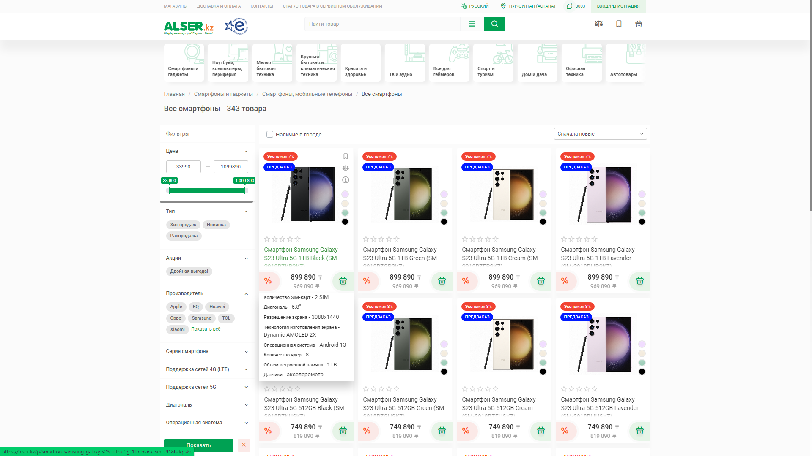

For parsing I choose Puppeteer. Puppeteer is a Node.js library which provides a high-level API to control Chrome/Chromium over the DevTools Protocol. Puppeteer runs in headless mode by default, but can be configured to run in full (non-headless) Chrome/Chromium.

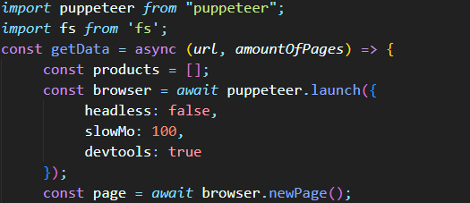

Here I imported this library and prepared the base code. This part of code open new browser, then open new page inside this browser. Everything inside the function **getData** with two arguments. **Url** need to send the link of page, where will be parse. **amountOfPages** it is the last number in pagination.

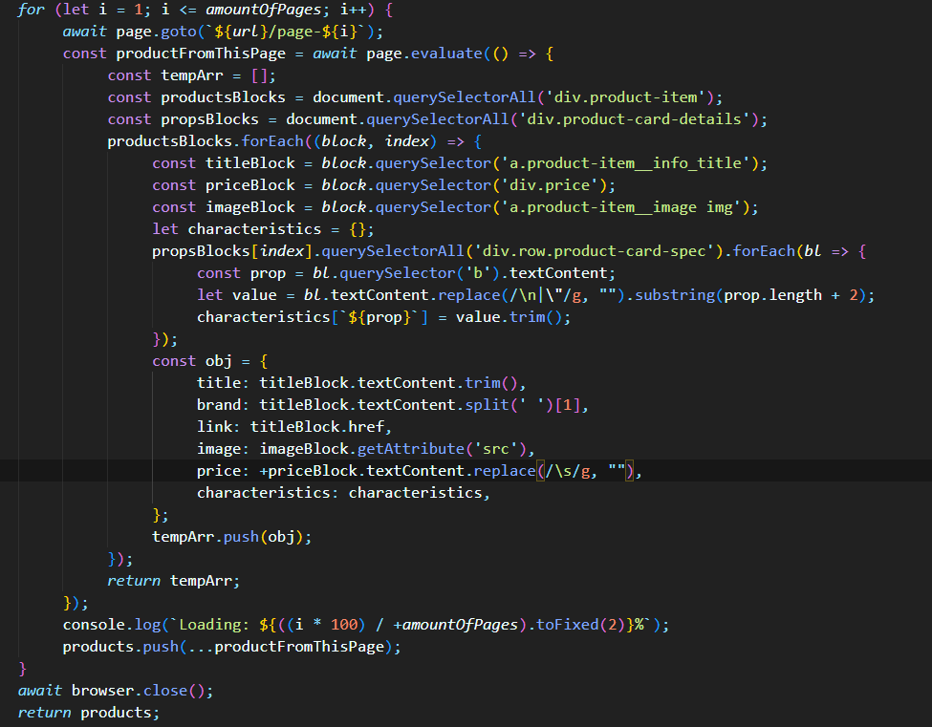

By this **amountOfPages** I created for-loop, here will be parsing. First of all, I had to retrieve the main blocks of phones (document.querySelectorAll(‘div.product-item’)),

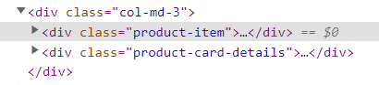

and then by **forEach** get necessary blocks. By this logic I got



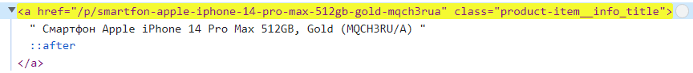



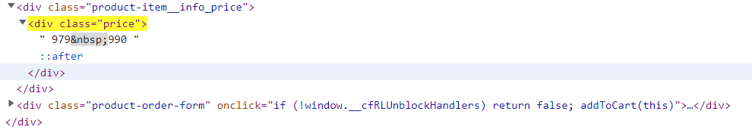





Right now, these variables contain DOM elements, and I need to retrieve the text from these blocks.

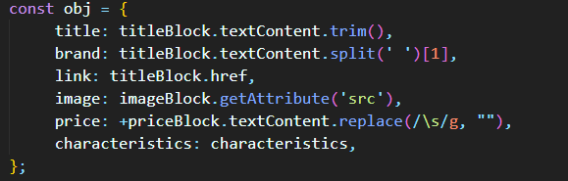

For this I used different operations. To get link and image method **getAttribute** was enough, but for example, to get price first of all I used **replace** with RegExp to delete all of the spaces, and then transmit this String to Number by using **+**. After all of these operations, I just used **push** to add this object to array and returned this array. 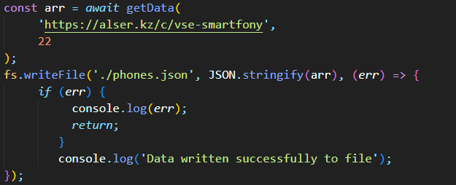Here you can see how I called this function, and use **writeFile** to create json file with this data.

After this, I used **mongoimport** to import this json file to MongoDB.

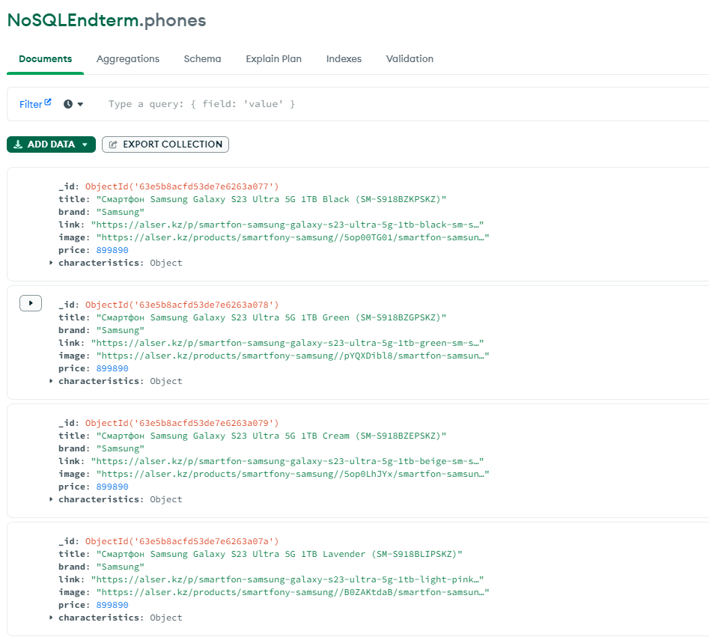

Then I writed some CRUD opearions:

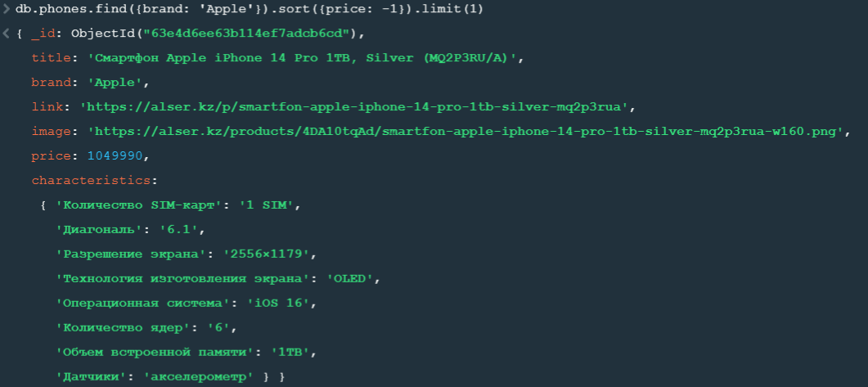

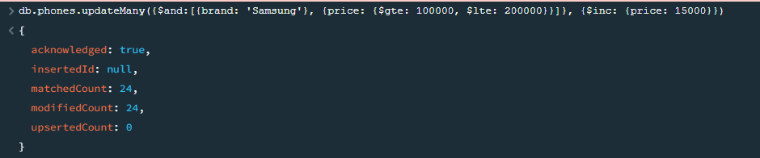

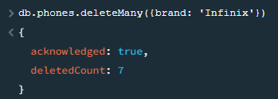

Here you can see the data analysis from MongoDB Compass:

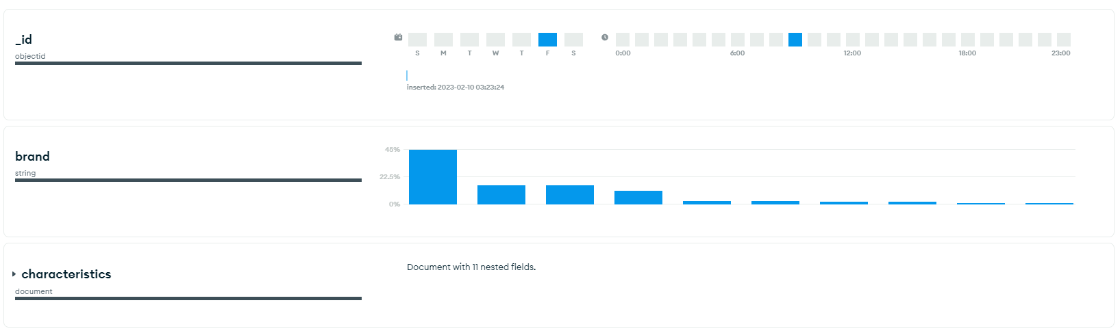

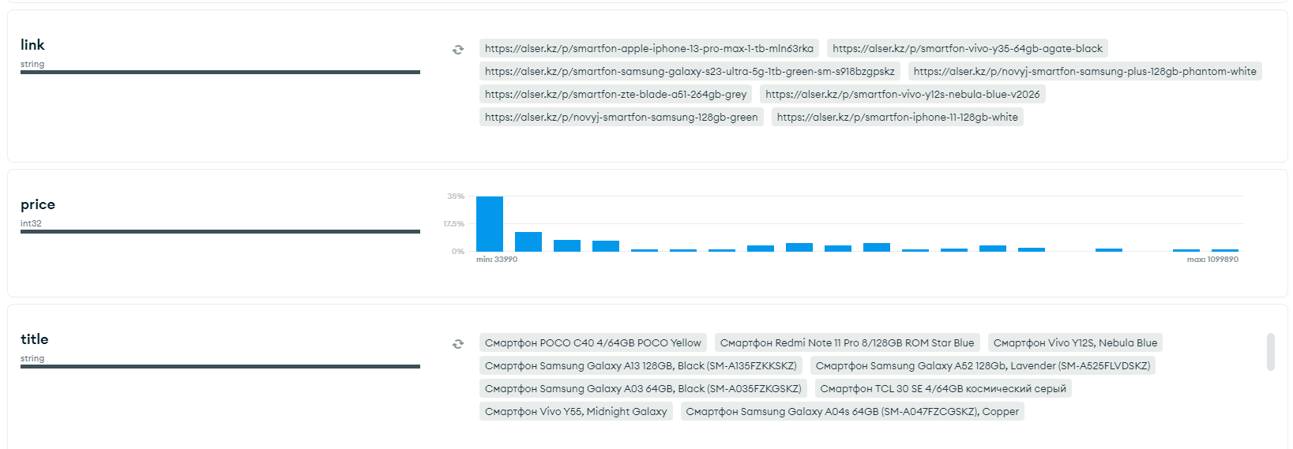

And visualization of it by some graphs:

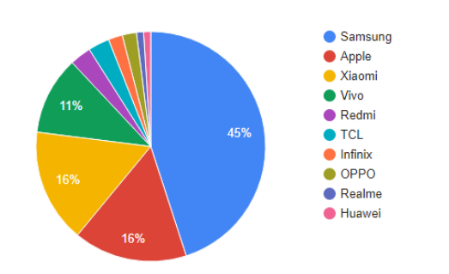

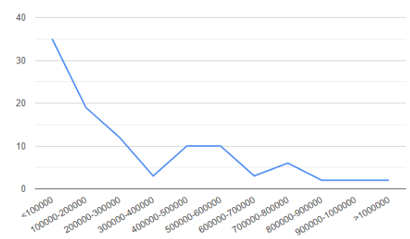

To show this data I used just HTML/CSS/JS. In the beginning, I created function **getResource** to fetch data from json file.

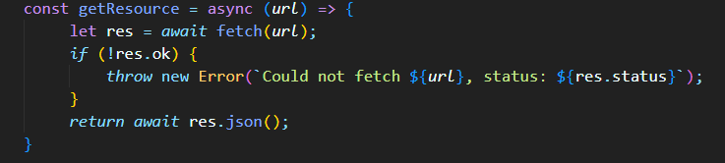

Then created function **createCard** to display object:

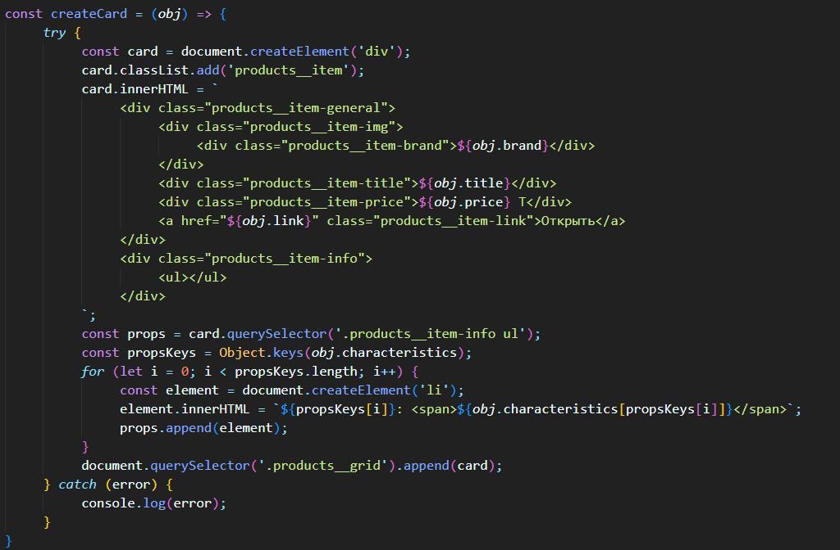

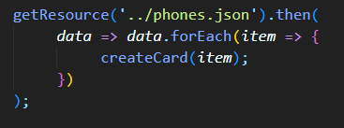

There is the result:

